Young Wife’s Guide

What Makes Young Wife’s Guide Unique:
Jami Balmet

Passionate about encouraging women to embrace their God given femininity, and giving them the tools to thrive in their homemaking.

Website:
YoungWifesGuide.com
Twitter:
@youngwifesguide
Email:
Jami@YoungWifesGuide.com

Owner & Regular Contributor to:
A Biblical Marriage
Homemaking From Scratch

Owns and Designs at:
Fount of Inspiration

Young Wife’s Guide has a devoted following of women both young and old who have a passion for Biblical homemaking. Tips on homemaking, hospitality, natural living, cooking, baking, decorating, living a strong and devoted Christian life, gardening, and marriage are all topics frequently covered. Blog posts are regularly scheduled Monday through Friday, 5 days a week.

Our Audience:
99% of our readers are well educated women. Most of our readers are married in their twenties and thirties and many have young children. They have a strong desire to be homemakers and many are stay-at-home mothers. Giveaway Opportunities:
Statistics

Monthly Visitors: 27,000+
Monthly Unique Visitors: 22,000+
Monthly Pageviews: 45,100+

Social Media Reach
Rss/Email Subscribers: 7900+
Facebook Fans: 6,500+
Twitter Followers: 1,100+
Pinterest Followers: 3,200+
Giveaways are a fun way to introduce my readers to your products. I ask that the company ship the prize directly to the winner. In return, I will provide:
- A post dedicated to a review of your product, with multiple links to your website and any content you would like to highlight
- Daily promotion of the giveaway on Facebook and Twitter

*Note: All sponsored posts/giveaways are marked as such in order to comply with FTC regulations.
Advertising Packages:
Ad Package 1
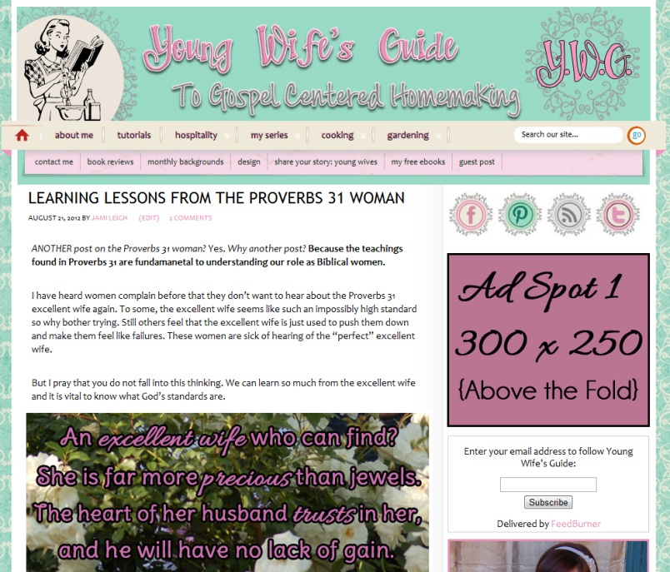

Includes:
- 300x250px ad spot above the fold
- Dedicated sponsored post (giveaway optional)
- An image link in the RSS feed’s footer
- Minimum 4 Tweets/Facebook mentions

Cost of Sponsorship:
$150/ 1 Month; $225/ 2 Months; $350/ 3 Months
Ad Package 2

Includes:
- 125x125px ad spot
- Dedicated sponsored post (giveaway optional)
- a text link mention in the RSS feed’s footer
- Complimentary Tweet/Facebook mention

Cost of Sponsorship:
$100/ 1 Month; $150/ 2 Months; $200/ 3 Months

Advertising A La Carte:
Sidebar 150X150px: $25/Month
Sidebar 300X100px: $25/Month
Sidebar 300X250px: $50/Month
Sponsored/Giveaway Post: $100/500 words (live for 12 months) {Plus free item to review if desired}

